Nora Olcott
Danielle Gray
English 201: Advanced Composition
February 12, 2019

Semiotics and the Human Skull

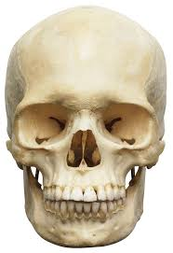(1)
Fig. 1 Human skull, DK Findout!

The human skull; living tissue which by the intramembranous ossification of collagen and calcium forms a bone structure by which not only an individual can be recognized but also forms the protection around the human brain, the control center of the human body. (Fig 1) As a standalone signified image, the human skull represents the group of twenty-two bones which are connected and sit atop the human skeleton. This signified is well-recognizable to the viewer within all parts of the world since it is after all, a human skull. Chandler states, “The more a signifier is constrained by the signified, the more 'motivated' the sign is: iconic signs are highly motivated; symbolic signs are unmotivated. The less motivated the sign, the more learning of an agreed convention is required” (Semiotics for Beginners, Signs). The human skull is highly motivated; there is no learning curve to understand it. All human beings whether living in a thriving metropolis or the jungles of the Amazon rainforest – all people are able to distinguish a human skull. But when one is presented with an image of this structure, the signifiers that come to the viewer’s mind can be linked to death, religion, cultural beliefs, medical interest, or social connotations. With this thought, the signified does not need to be directly linked to its actuality. As Daniel Chandler shares in Semiotics for Beginners, “Although the signifier is treated by its users as 'standing for' the signified, Saussurean semioticians emphasize that there is no necessary, intrinsic, direct or inevitable relationship between the signifier and the signified” (Semiotics for Beginners, Signs, (SBS)). This can be said of the human skull and its connotations which do not have direct relationship with the actual bone structure.
The connotations of the skull vary between cultures, genres, medical practices, religions, and media communication. Saussure states, “There is no one-to-one link between signifier and signified; signs have multiple rather than single meanings” (SBS). This can be seen within the multiple meanings of this single sign when analyzing the use of the human skull to represent various connotations. While the most common images one may see in our culture could be on front of a t-shirt, or tattooed on an arm, throughout history and the world, skulls have been used to draw attention, whether it is to demonstrate good vs evil, death or mortality, celebration of life, depiction of a villain, or a symbol of knowledge – skulls can be found in every culture. What is our fascination with this part of our body and what connotations does this image bring the viewer? Are we obsessed by this particular shape because it is what creates the very shape of our face, the world’s view of ourselves? Or does this fascination stem from the obsession with death that has coursed through humanity since the beginning of time?
Maybe this fascination comes from the fact that among the bones in the human body, the skull tends to ‘outlive’ the others. This piece of the skeleton is thick and strong, creating a stronger force against the decomposition of time. Anthropologists have found that the skull can provide the age and ethnicity of the deceased – and facial reconstruction of a skull can provide a view into the past appearance of the person themselves. This cannot be said of any other group of bones in the human skeleton. The skull provides a sense of self, the individual image of a particular human being.
(2) (3)
(4)
Fig. 2 Disney’s Pirates of the Caribbean promotion, Pinterest.com
Fig. 3 Marvel’s Punisher, Amazon.com
Fig. 4 Skull emoji, readunwritten.com
Or maybe it is the connotations brought to the viewer through media which usually contains a variable of danger or death. Speaking about the cohesiveness of the connotation, Chandler shares, “The relation between a signifier and its signified is not a matter of individual choice; if it were then communication would become impossible” (SBS) This statement reveals the concept that there must be a consensus of a sort as to what the signified represents, otherwise the connotation is lost to the individual. Media companies have created a monopoly on the concept of bringing the viewer a sense of danger or thrill by using the skull sign. While one may expect skulls to adorn promotional items for horror movies, other media entertainment companies have found the skull to be a quite lucrative symbol. The people of Disney have flooded the market with skull covered merchandise under the movie series title, Pirates of the Caribbean. (Fig. 2) Turning to the comic conglomerate, Marvel, one is presented with The Punisher symbol which is an elongated skull with long teeth, the symbol representing the type of justice coming to unscrupulous criminals. (Fig 3) No surprise, the skull has even made it into the emoji status. This connotation differs a bit from the other usages as shown above, though some may argue the skull’s emoji gives a nod toward the connotation of death; this implication is more a symbol of feeling like dying. (Fig. 4) The skull emoji is used to rate your hangover; one skull may express a need for some hair of the dog that bit you, while five announces you will not be leaving your bed anytime soon. Not all media use portrays or connotes the skull with danger and death, but a large majority leans that direction.
(5) 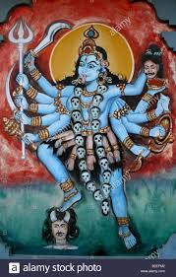(6)
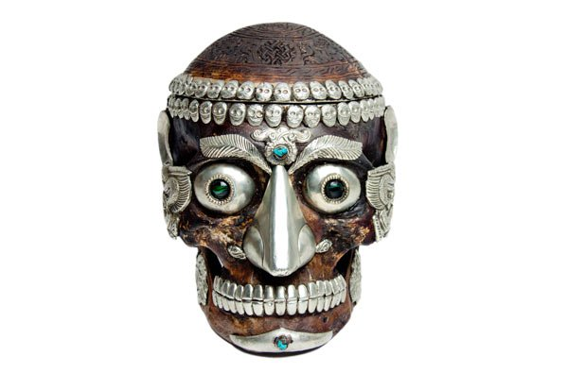(7)
Fig. 5 Golgotha, the crucifix of Christ, Jamesstabor.com
Fig. 6 Mural on a Hindu temple wall of the Hindu goddess Kali, India, Louise Batalla Duran / Alamy Stock Photo.
Fig. 7 Ancient Kapala skull cap, ancient-origins.net
Within religious circles, the skull has a variety of conflicting connotations. When one looks at the Bible used in conjunction with the Christian faith, the Scriptures only use the word ‘skull’ in the context of Jesus Christ’s crucifixion. Jesus is taken to Golgotha which, in the Aramaic, translates to ‘the place of the skull’ where Jesus was crucified. (Fig. 5) In this religious connotation, the skull is representative of a tortuous death. There is also Scriptural basis to ponder in reference to the creation of the human skull. In Genesis 1:27, the Bible states, “…God created mankind in his own image.” Would this not make man’s skeletal shape of great significance? By this thought, the implication of the skull could be said to be tied to the connotation of immortality. In contrast, within the Hindu religion, the skull is used in independent imagery to signify different meanings. The Hindu goddess Kali, wears a garland of human skulls, to represent infinite knowledge (thespeakingtree). (Fig. 6) There is also the implication that the skulls representing Kali’s ability to vanquish of negative emotions (vajranatha.com). The skull’s use goes beyond these connotations within the Hindu and Buddhist religions where it is used as a physical vessel. (Fig 7) In these religious rites, these religions use the human skull as a type of bowl calling it a kapala which is Sanskrit for skull. This is deemed a ‘wisdom vessel.’ These skulls are elaborately decorated and used to appease wrathful deities (ancient-origins.net). While many religions regard the skull by the same connotations as Christianity – mainly as a symbol of death and mortality – many religions use the image differently, welcoming its shape into their everyday worship.
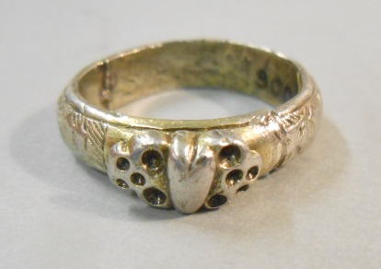 (8)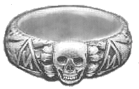(9) (10)
Fig. 8 Silver gilt ring, the applied bezel with a heart between two death’s heads, artofmourning.com
Fig. 9 SS Totenkopfring, jewishvirtuallibrary.org, coutesy of U.S National Archives
Fig. 10 Totenkopfverbande ring worn by Nazi SS officers, adl.org

There is historical use of the skull sign outside of its obvious religious connotations. From the Middle Ages to Modern, skulls have been used for different proclamations. While most are centered around memento mori , Latin for ‘remember you will die,’ the skull has been used in other contexts as well. In the early 16th and 17th Centuries, the ‘death head skull’ was a popular symbol used in artistry. Wedding rings with two skulls found on either side of a centered heart signified the bonds of marriage until death, not as a symbol of pending doom but in the recognition of love and a new life together.(Fig. 8) At this same time, one could wear a similar ring signifying the death of a loved one. (Fig. 9) By the early 1930s, the ‘death’s head ring,’ or Totenkopfring, became a symbol worn by Nazi SS officers and “…later it became the symbol of the SS-Totenkopfverbande …whose purpose was to guard the concentration camps” (adi.org). (Fig. 10) The skull ring concept went from the original connotation of love within a marriage, to mourning, to a common symbol of hate associated with the Nazis. While there is representation of skulls throughout history, these three conflicting connotations stand out in historical times.
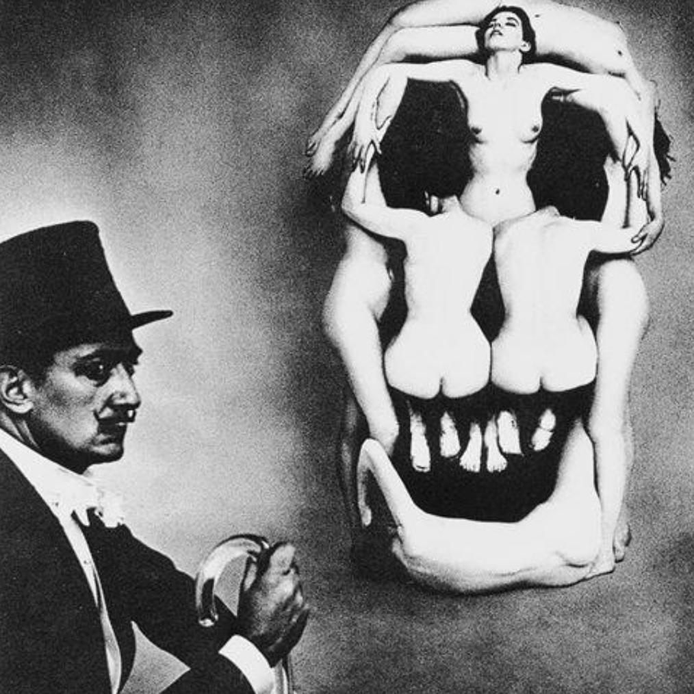 (11) 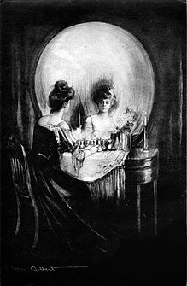(12)
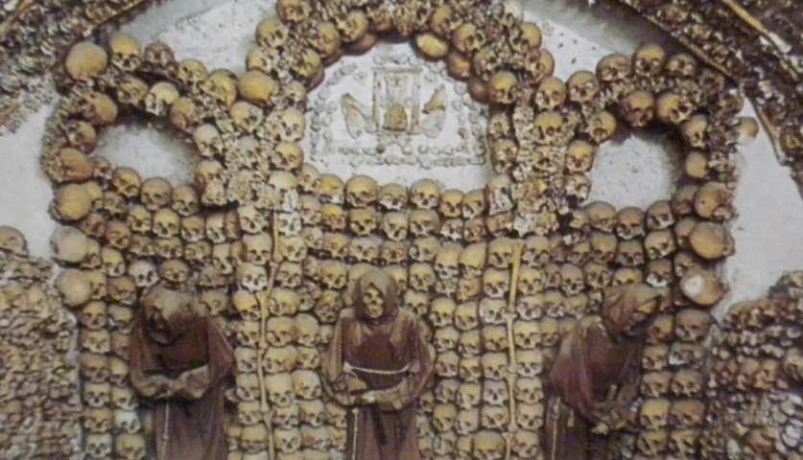 (13)
Fig. 11 Salvador Dali In Voluptus Mors (1951), theransomnote.com
Fig. 12 Charles Allan Gilbert, All Is Vanity (1892), public domain, wikipedia.org
Fig. 13 Triptych formed by skull, The Cemetary of the Capuchin Fathers, Church of the Immaculate Conception, Rome, Italy, richardcassaro.com

The signified image of the skull can be found in other forms of historical significance and continues to be present within these forms. The thought that “the meaning of a sign is not contained within it, but arises in its interpretation” (SBS) can be seen in the use of the skull in art. The connotation of the skull is brought to the viewer as an object of beauty. One could argue that any portrait is truly an image of the human skull, albeit covered in flesh, but still revealing the same skull that sits atop our bodies. While tattooing a skull on one’s body may be a representation of a lost loved one or an interest in the occult, artists throughout the centuries have had a fascination with this human shape. Surrealist, Salvador Dali, in collaboration with Philippe Halsman, photographer, created In Voluptas Mors, or Voluptuous Death, a portrait containing seven naked women posed into the shape of a skull. (Fig. 11) Even though this is a nude piece, the women’s nudity is not what first draws the viewer’s attention. Chandler states, “Even the most 'realistic' image is not a replica or even a copy of what is depicted. We rarely mistake a representation for what it represents.” When one first views Dali’s masterpiece, it is the shape that one sees before recognizing the objects which were used to convey. Charles Allen Gilbert’s, All is Vanity, presents the viewer with a woman at a mirror – but when the viewer takes in the whole of the picture, one actually sees a skull, reminding the viewer that beauty is only skin deep but inner beauty brings immortality. (Fig. 12) In another type of art form, the remains of 4,000 Capuchin friars are sculpted into a triptych. Richard Cassaro, author and historian, explains “The intention here is not to scare but to inspire prayer, contemplation, deep thoughts, and meditation”(richardcassaro.com). The skull continues to carry fascination among artists and art collectors, each individual holding its own set of connotations and conceptual realities involved within the pieces.
(14) (15)
Fig. 14 Willie G. skull logo, Harley Davidson Motorcycle Company, lezebre.lu
Fig 15 Harley Davidson Motorcycle logo, quickthrottle.com
For the motorcycle rider, the skull has been a symbol used for decades. The sign of the skull became so synonymous with motorcycles that Harley Davidson, a leading manufacturer of motorcycles, who had- and still - uses their familiar black and orange logo, created a new logo to coincide with the old – one including the skull. (Fig 14, 15) This black and white, or black and silver, image brings a more sinister feel than its steady counterpart which displays the company’s name alone. And yet, though motorcycle riding carries a thrill of danger, the skull is not seen within these ranks as a sign of death, rather it is looked at as a sign of comradery, segregation, and commitment. Taking advantage of the connotations of evil some associate with the skull, the motorcycle riders look to the skull as a way of segregating those who may not have the same view on life. A ThrottleX Blog writer explains, “By displaying skull symbolism on ourselves, we’re using it as a filter to bring in people who identify with us and drive away people that don’t” (throttlexbatteries). The inclusion of the skull in no way points to the impending doom of the rider, instead it reminds the rider to live each day to the fullest, to live a life of freedom, to fearlessly let the wind flow through your hair. The skull is also a talisman for the biker. It is believed that when Death himself comes, he leaves a mark on the deceased; but by wearing the skull symbol, Death will pass over you, believing he has already marked you. This creates a sense of immortality for the biker and continuity of the club – and use of the skull - for centuries to come.
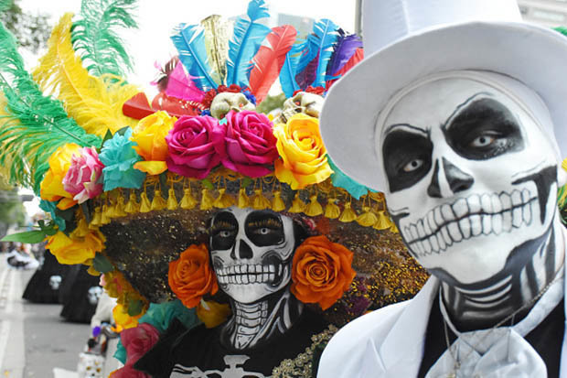(16) 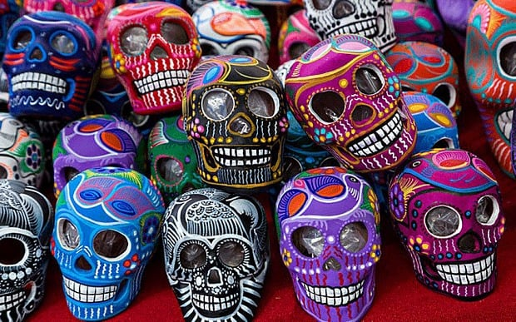(17) Fig.16 Day of the Dead participants, dailystar.co.uk
Fig. 17 Sugar skulls, Day of the Dead, popsugar.com

One of the most recognized forms of use of skulls comes from the Dia de los Muertos, or Day of the Dead. This Mexican holiday finds its roots in traditions dating back to the Aztec and other indigenous tribes. While the name has its own implications, it is actually a celebration of life and welcoming home of the spirits of those lost. While the streets are filled with skull decorations and parades of skeleton painted people, the graves of those deceased are elaborately decorated. This is not a Halloween celebration, but a celebration in respect and memory of a loved one lost, and in celebration of their life.
So what is our fascination with the skull? And why so many different connotations? By reviewing these different connotations brought by the usage of the skull as a signified, are we able to draw a simple conclusion to the value placed on its shape within society? Chandler shared, “David Sless declares that 'statements about users, signs or referents can never be made in isolation from each other. A statement about one always contains implications about the other two' (Sless 1986, 6)” (SBS). With this in mind, one has to include the observations and experiences of the viewer, the sign itself, and then what the sign could signify to society as a whole. Since the beginning of time, society has obsessed over death and the afterlife so it would make sense to conclude the abundance of this symbol drives this course of interest. But the use of the skull is not only for purposes of the macabre; as a teenager wears a t-shirt with a red, white, and blue skull emblazed on its front, is this teen thinking of death? By most opinion, this age group feels themselves to be invincible, so the thought that death could be looming would not fit under this scenario. Or in our society ridden with vanity and the desire to be young and beautiful, is it practical to give credence to the idea this sign represents the facial form in which we are drawn to for companionship and love. Though one may never consider they are in love with an individual’s skull, those in love can admit to being attracted to the facial form of their loved one. So maybe the use of the skull, by combining these main connotations into a cohesive conclusion, brings a simple signifier to be considered: the connotation of the unknown. For the simplifiers of life and love is filled with the unknown until one experiences it – and death would certainly fall within the same guise.

Works Cited
Aprilholloway. “The Practices and Rituals of Tibetan Kapala Skull Caps.” Ancient Origins,
Ancient Origins, 7 Feb. 2014, www.ancient-origins.net/ancient-places-asia/practices-and-
rituals-tibetan-kapala-skull-caps-00945.
The Holy Bible, Containing the Old and New Testaments. American Bible Society, 2000.

“KURUKULLA.” John Myrdhin Reynolds/Vajranatha, www.vajranatha.com/teaching/Kurukulla.htm.
“The Meaning Behind 10 Confusing Emojis.” Unwritten, 2 Apr. 2015,
www.readunwritten.com/2015/04/02/meaning-behind-10-confusing-emojis/.

“The Occult Secret of the ‘Skull & Cross Bones’ Symbol.” Richard Cassaro, 27 Dec. 2016,
www.richardcassaro.com/the-arcane-meaning-of-the-skull-cross-bones-symbol/.
Semiotics for Beginners by Daniel … - Visual-Memory.co.uk. Visual-
memory.co.uk/Daniel/Documents/S4B/.
“Skull Symbolism in Motorcycling: What Does It Mean?” ThrottleX, 21 Mar. 2018,
www.throttlexbatteries.com/uncategorized/skull-symbolism-in-motorcycling-what-does-
it-mean/

Thakur, Pallavi. “Kali: Goddess of Sex, Desire, Death?” Speakingtree in, Speaking Tree, 28
Aug. 2014, www.speakingtree.in/allslides/kali-the-goddess-of-sex-desire-death/182190.
“Totenkopf.” Anti-Defamation League, www.adi.org/education/references/hate-
symbols/totenkopf.

Images Cited
(Fig.1) https://www.dkfindout.com/us/human-body/skeleton-and-bones/skull/
(Fig. 2) https://www.pinterest.com/pin/113715959326423873/?lp=true
(Fig. 3) https://www.amazon.com/Punisher-Skull-Flag/dp/B01GQX8NJ4
(Fig. 4) https://www.readunwritten.com/wp-content/uploads/2015/03/Unknown-5.jpeg
(Fig. 5) https://jamestabor.com/locating-golgotha/
(Fig. 6) https://www.alamy.com/stock-photo-mural-on-a-hindu-temple-wall-of-the-hindu-goddess-kali-
india-18759330.html
(Fig. 7) https://www.ancient-origins.net/ancient-places-asia/practices-and-rituals-tibetan-kapala- skull- caps-00945
(Fig. 8) http://artofmourning.com/2015/08/06/the-earliest-mourning- ring/?doing_wp_cron=1514521944.9722070693969726562500
(Fig. 9) https://www.jewishvirtuallibrary.org/ss-totenkopfring
(Fig. 10) https://www.adl.org/education/references/hate-symbols/totenkopf
(Fig. 11) https://www.theransomnote.com/culture/articles/dreamers-awake-the-women-of-
surrealism-are-fighting-back/
(Fig. 12) https://en.wikipedia.org/wiki/Charles_Allan_Gilbert
(Fig. 13) https://www.richardcassaro.com/the-arcane-meaning-of-the-skull-cross-bones-symbol/
(Fig. 14) https://lezebre.lu/motocycle-decals/par-marque-a-z-en/harley-davidson-decals/harley-
davidson-skull-decal/
(Fig. 15) https://quickthrottle.com/harley-davidson-findyourfreedom-interns-announced-meet- the-eight-interns/
(Fig. 16) https://www.dailystar.co.uk/news/world-news/740177/Day-of-the-Dead-Mexico-Dia- de-los-Muertos-facts-why-celebrated (Pic:Getty)
(Fig. 17) https://www.popsugar.com/latina/What-Day-Dead-43897468 Image source: Flickr
user Eva Rinaldi

