Brian Dickinson
Professor Danielle Gray
English 201
10 February 2019
Semiotic Analysis of
Authority Signifiers

The concept of authority can be found almost anywhere in the world, affecting society as it occurs in both the animal kingdom and human interaction. The following analysis will be centered around the latter, but the same thread runs through both worlds: Effective authority requires evidence of veracity. More specifically, effective authority requires observable signs that display its nature, source, and range. Without recognizable signifiers, figures of authority do not have the necessary authority to effect the world around them with maximum effectiveness.
Fig. 1. Honey bees, https://agdev.anr.udel.edu/maarec/honey-bee-biology/the
-colony-and-its-organization/
An examination of the animal kingdom provides a good starting point for the analysis of the concept of authority signifiers. One popular example of this concept is the honey bee (Figure 1). Studies conducted by the Mid-Atlantic Apiculture Research and Extension Consortium (MMAREC), show that “A queen is easily distinguished from other members of the colony. Her body is normally much longer than either the drone’s or worker’s... Her wings cover only about two-thirds of the abdomen, whereas the wings of both workers and drones nearly reach the tip of the abdomen when folded. A queen’s thorax is slightly larger than that of a worker, and she has neither pollen baskets nor functional wax glands. Her stinger is curved and longer than that of the worker, but it has fewer and shorter barbs.” In summary, the highest priority member of the hive holds key identifying characteristics by which she is recognized by scientists and her fellow bees. But physical attributes alone do not necessarily indicate authority. Wolves At Our Door, a book written by Jim and Jamie Dutcher, describes how an animal’s activity can set it apart from other members of the group in which it lives. The book describes how wolves of higher authority will eat first, display dominance through eye contact, and demonstrate superior strength through fighting with other members of the pack.
Having established that physical attributes and activity can act as authority signifiers in animals, can we observe similar signifiers in human behavior through semiotic analysis of people in authority? David Chandler tells us in his book, Semiotics for Beginners, that semiotics “...includes words, sounds, and body language.” So this analysis should examine at least these three attributes in authority figures.
Police officers are important figures of authority in many countries, and they happen to be a good example of one of the major signs of authority, uniformity. Police are trained in many countries to stand with certain postures in different scenarios. The angle of their bodies and the placement of their hands are predetermined by a set of guidelines. This body language is constructed to serve as a communication tool allowing officers to have greater control over unpredictable situations. When a police officer puts their hand on their gun, it is with the intent to deter unwanted responses from the people they deal with. Most police officers stand with straight backs, feet shoulder-length apart. When you see a police vehicle behind yours turn on its strobing blue and red lights, the sound of the siren triggers a command without words: “Pull over to the side of the road and await further instruction.” Identifying words like “Police” and “FBI” can be found on the clothing and property of law enforcement officers. We might see images of a shield used as badges for these officers, an important sign in and of itself. The shield is a protective item used to deflect harm. Its connotations include safety, strength, and fortitude. It is no mystery why it is often used by law enforcement, as the intent of the organizations involved in that effort is to protect and serve the people subject to their authority (Figure 2).
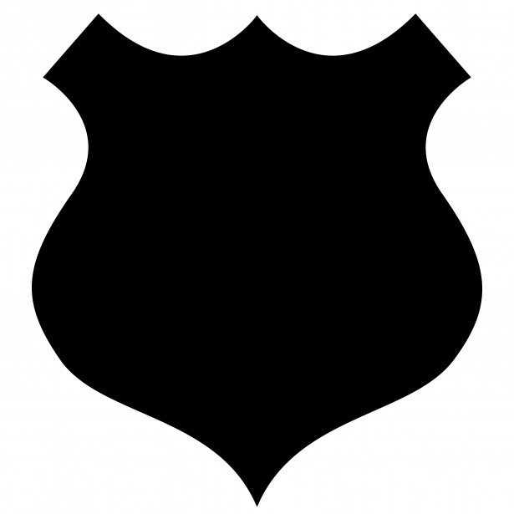
Fig. 2. Shield image, https://www.publicdomainpictures.net/en/view-image.php?image=37232&picture=badge-shield-black-clipart

As with all symbols and images, interaction with the bearers of these signs train us to respond certain ways. If we have only had negative interactions with the authority behind the signal (i.e. a shield on a badge or police vehicle), we will tend to respond negatively in return. Chandler confirms this point when he informs us that the three attributes that make up semiotics are: “Semantics”, “Syntax”, and “Pragmatics”. Pragmatics being the relationship of signs to interpreters.
The semantics of signs of authority are clear for the most part when it comes to law and order, but they are not always so with other authority signifiers in human society. A college degree is a good example of that concept. We consider someone an ‘authority’ on a subject if they have a great deal of education or experience with it. A symbol of that authority could be a degree or a certificate, containing words and signatures that lend themselves to the credibility of the document. Such a certificate means that someone has earned recognition through intensive study of a subject, granting them influence over those who lack the same experience. However, there are many different universities and organizations through which one can obtain similar certifications. Without uniformity of standards across all accredited universities, we could never be truly sure of the semantics behind that degree. Again, uniformity surfaces as a key element in authority signifiers.
It seems that it is easier to identify authority when it is influencing you than it is to recognize authority when you hold it yourself. As Chandler says, “The selectivity of any medium leads to its use having influences of which the user may not always be conscious, and which may not have been part of the purpose in using it.” In other words, it can be difficult to see what makes other people consider us an authority figure if we have become accustomed to acting in that role. Chandler refers to this concept as ‘anaesthetization’.
An example of ‘anaesthetization’ is another authority signifier, wealth. Wealth produces authority through an increase in the ability to influence the people and systems that surround it. Wealth allows for the purchase of finer cars, clothes (Figure 3), housing, and ease of access to higher education. However, without comparison, it can be difficult to detect who is wealthy and who is not. The construction worker might not see himself as wealthy, but the vagrant would say that he is. Again, pragmatics functions as a quality of this particular signifier, as we will react to wealth in varied ways depending on our past with that signifier.
Fig. 3. The Boss Photo, https://images.unsplash.com/photo-1507679799987-c73779587ccf?ixlib=rb-1.2.1&ixid=eyJhcHBfaWQiOjEyMDd9&auto=format&fit=crop&w=1051&q=80
Why does uniformity come into play so often when it comes to authority signifiers? What does that tell us about the evolution of these signs? Uniformity provides ease of recognition in those being influenced by authority, and streamlines the response desired by the authority bearer. For this principle to function efficiently, it is necessary for those that bear authority to be readily recognizable somehow. Hence the signifiers that inform the influenced of the nature and general intent of that authority.
As the influenced interact with the authority bearers, their perception of the authority itself changes, and so does their reaction to the signs that represent it. As the reaction to authority changes, so does the authority itself, tailoring itself to the society around it so that it may continue to induce the desired effect from the influenced. This constant state of flux between authority bearers, the influenced, and the authority itself is the framework of the evolution of most of society’s command structures. We may use American political government as an example. A political official runs for office, using authority signifiers to influence the systems of people that make up their voter base. These signifiers include symbols of wealth (i.e. suits and jewelry), symbols of party affiliation (red or blue neckties), and the words they use (usually more eloquent diction that indicates education, another authority indicator). After an elected official obtains office, the decisions that come out of that office are scrutinized by the influenced parties and used as a measuring stick of sorts with which the next election will be analyzed. (President X’s administration produced this decision with this outcome, So President Y with similar authority signifiers will probably result in the same decisions and outcomes.)
This semiotic analysis leads us to a few conclusions. First, authority and uniformity of the signifiers related to it are directly connected. Second, those signifiers evolve through the influence they have on society at the individual and mass-scales. Finally, we have confirmed that authority signifiers exist beyond human development and stem into the animal kingdom, which may mean that the importance of signals of authority has a more innate existence that it first appears. How does knowing all of this help us as a society? It may be that simply understanding the process of authority and the signifiers it uses can help us to look more objectively at the systems of authority at work in our own lives. We can analyze the sign more deeply when we understand where it comes from as well as who is holding it.

Works Cited
“The Colony and its Organization.” MAAREC - Mid-Atlantic Apiculture Research and Extension Consortium, 19 Oct. 2010, https://agdev.anr.udel.edu/maarec/honey-bee-biology/the-colony-and-its-organization/.
Dutcher, Jim and Jamie. Wolves At Our Door, Simon and Schuster, 2002.
Chandler, Daniel. “Introduction.” Semiotics for Beginners: Denotation, Connotation and Myth, visual-memory.co.uk/daniel/Documents/S4B/

